OASYS INSTITUTE OF TECHNOLOGY
PULIVALAM, TRICHY – 621 006.
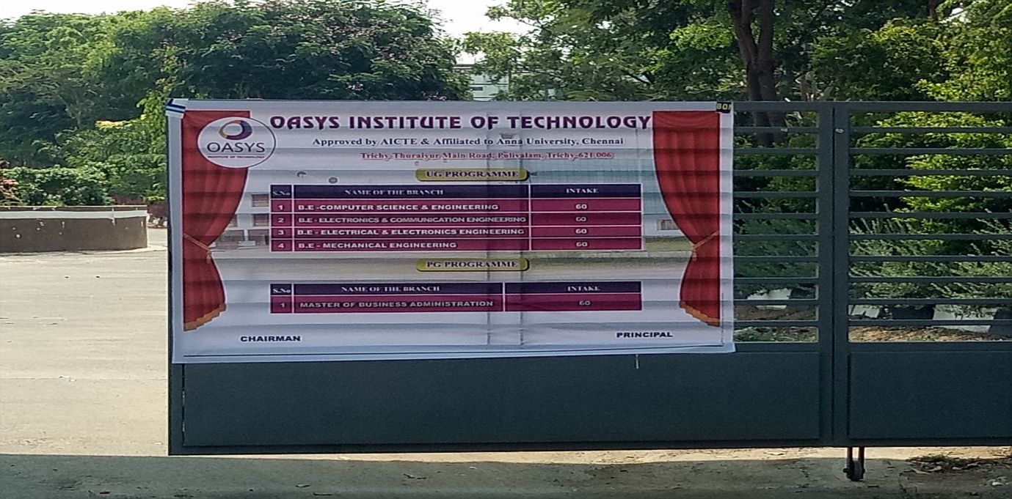
Photos: Course and approved intake status displayed in
Entrance gate.
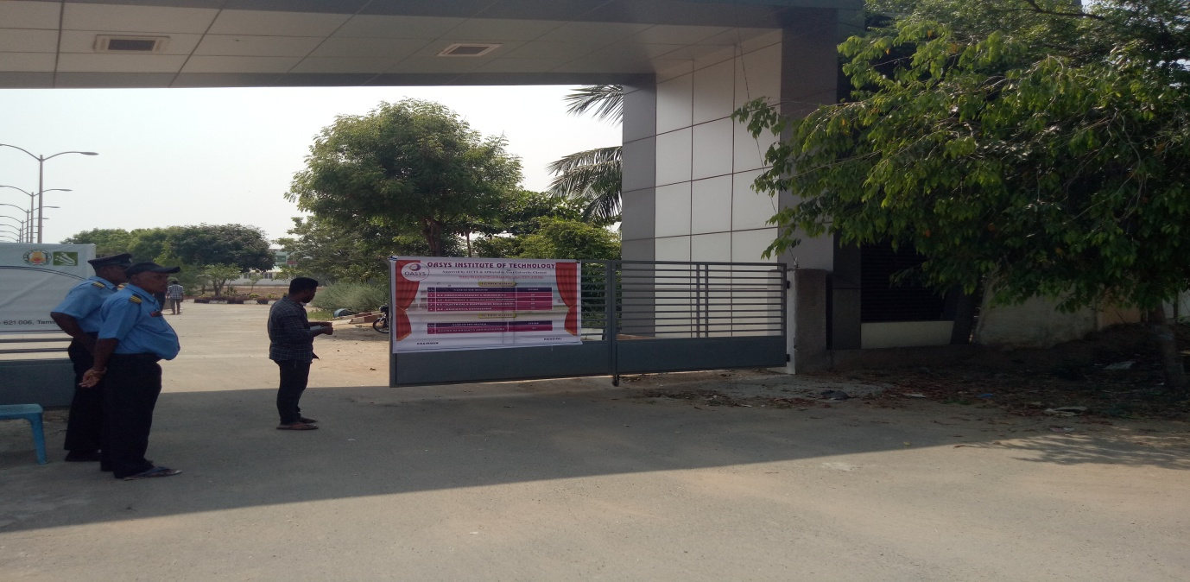

Photos: Course and approved intake status displayed in
Entrance gate.

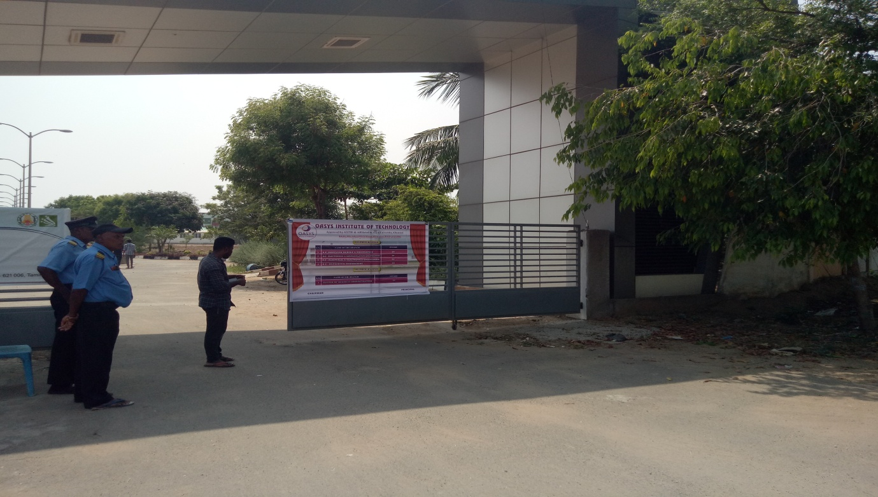

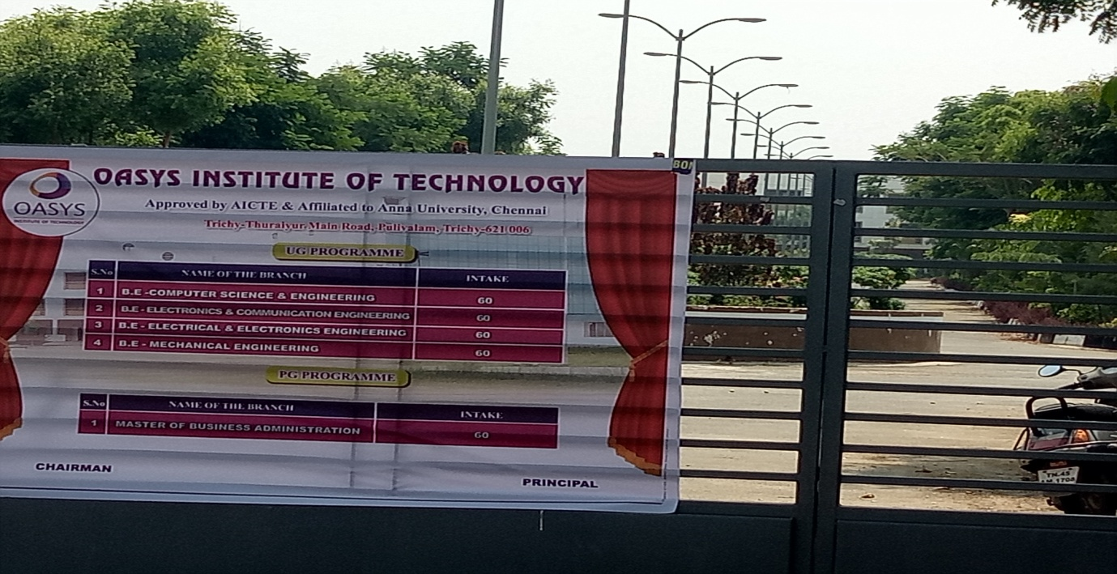

Courses and Approved intake entrance of the Institution

S. No. | Name of the Course | Approved Intake for the year  2021-2022
UG - Courses
1 | B.E - Computer Science and Engineering | 60
2 | B.E - Electrical and Electronics Engineering | 60
3 | B.E - Electronics and Communication Engineering | 60
4 | B.E - Mechanical Engineering | 60
PG - COURSES
1 | MBA – Master of business Administration | 60

